**23. FULL ADDER   
EXP.NO: 23   
AIM: To design and implement the full adder using Logisim simulator.  
PROCEDURE:   
1)      Pick and place the necessary gates.  
2)      Insert 3 inputs into the canvas.   
3)      Connect the inputs to the XOR gate, AND gate and OR gate.  
4)      Insert 2 outputs into the canvas.   
5)      Make the connections using the connecting wires.  
6)      Verify the truth table.   
TRUTH TABLE:  
  
   
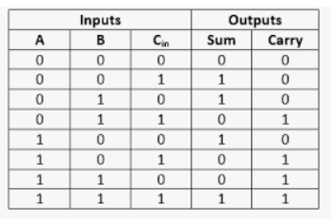  
Sum=(A⊕B) ⊕Cin  
  
Carry=A.B+ (A ⊕B)**

**Logical Diagram:**

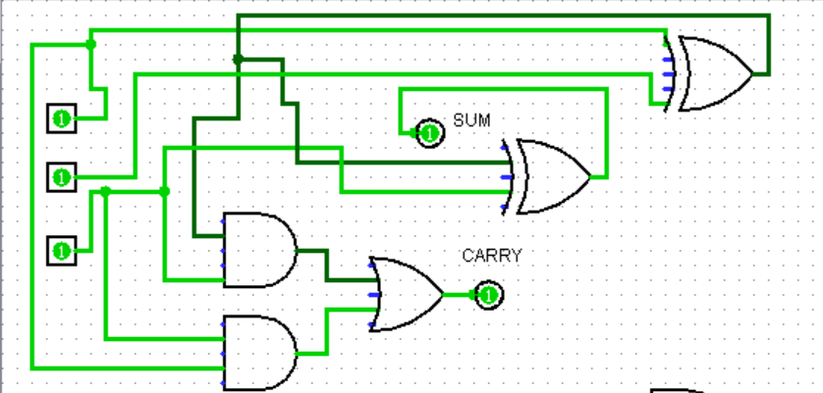

**Full adder using NAND Gates:**

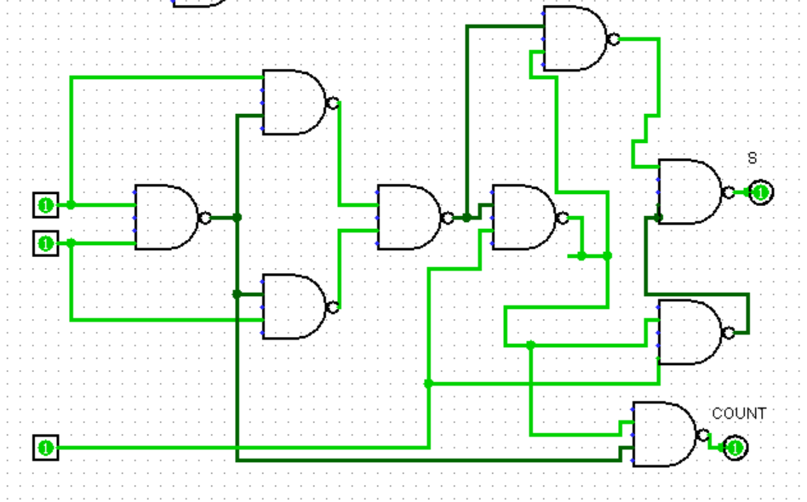

**Full adder using NOR Gates:**

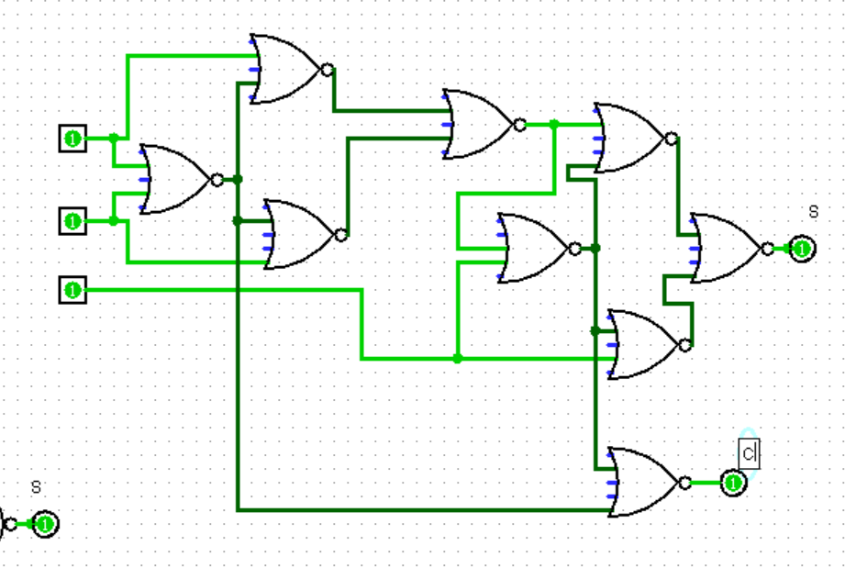

**RESULT: Thus full adder has been designed and implemented successfully using logisim simulator.**